Department of Trade and Taxes

Government of NCT of Delhi

**Form DVAT 01**

*[See Rule 5(2)]*

**PART - A**

**Application For Opting For Composition Scheme**

|  |  |  |  |  |  |  |  |  |  |  |  |  |  |  |  |  |  |  |  |  |  |  |  |  |  |  |  |  |  |  |  |  |  |  |
| --- | --- | --- | --- | --- | --- | --- | --- | --- | --- | --- | --- | --- | --- | --- | --- | --- | --- | --- | --- | --- | --- | --- | --- | --- | --- | --- | --- | --- | --- | --- | --- | --- | --- | --- |
| **1.** | TIN |  |  |  |  |  |  |  |  |  |  |  |  |  |  |  |  |  |  |  |  |  |  |  |  |  |  |  |  |  |  |  |  |  |
|  |  | | | |  |  |  |  |  |  |  |  |  |  |  |  |  |  |  |  |  |  |  |  |  |  |  |  |  |  |  |  |  |  |
|  |  | | | |  |  |  |  |  |  |  |  |  |  |  |  |  |  |  |  |  |  |  |  |  |  |  |  |  |  |  |  |  |  |
| **2.** | Full Name of Applicant Dealer | | | | | |  |  |  |  |  |  |  |  |  |  |  |  |  |  |  |  |  |  |  |  |  |  |  |  |  |  |  |  |
|  |  | | |  |  |  | |  |  |  |  |  |  |  |  |  |  |  |  |  |  |  |  |  |  |  |  |  |  |  |  |  |  |  |
|  |  |  |  |  |  |  |  |  |  |  |  |  |  |  |  |  |  |  |  |  |  |  |  |  |  |  |  |  |  |  |  |  |  |  |
|  |  |  |  |  |  |  |  |  |  |  |  |  |  |  |  |  |  |  |  |  |  |  |  |  |  |  |  |  |  |  |  |  |  |  |
|  |  | | |  |  |  | | |  | | | | |  |  | |  |  |  |  |  |  |  | |  |  |  |  |  |  |  |  |  |  |
| **3.** | Nature of Business | | |  | Trader | | | | Manufacturer | | | | | Works | | | | | | | | | Leasing | | | | | | Others | | | | |  |
|  | *(Tickall applicable)* | | |  |  |  |  |  |  |  |  |  |  |  |  | Contractor | | | | | | |  |  |  |  |  |  |  | (specify) | | | |  |
|  |  |  |  |  |  |  |  |  |  |  |  |  |  |  |  |  |  |  |  |  |  |  |  |  |  | _______ | | | | |  |
|  |  |  |  |  |  |  |  |  |  |  |  |  |  |  |  |  |  |  |  |  |  |  |  | |  |  |  |  |  |
|  |  | | | |  |  | | |  | | |  |  |  |  |  |  |  |  |  |  |  |  | |  |  |  |  |  |  |  |  |  |  |
|  |  | | | | |  | | | | | |  |  |  |  |  |  |  |  |  |  |  |  | |  |  |  |  |  |  |  |  |  |  |
| **4.** | Year for which composition scheme is sought* | | | | | | | | | | |  |  |  |  |  |  |  |  |  |  |  |  | | - |  |  |  |  |  |  |  |  |  |
|  |  | | | | |  | | | | | |  |  |  |  |  |  |  |  |  |  |  |  |  |  |  |  |  |  |  |  |  |  |  |
|  | * hereinafter referred to as “current year” | | | | | | | | | | |  |  |  |  |  |  |  |  |  |  |  |  |  |  |  |  |  |  |  |  |  |  |  |
|  |  | | | | |  |  |  |  |  |  |  | | |  | |  |  |  |  |  |  |  |  |  |  |  |  |  |  |  |  |  |  |
| **5.** | Turnover in the preceding year | | | | | |  |  |  |  |  | (Rs.) | | | | |  |  |  |  |  |  |  |  |  |  |  |  |  |  |  |  |  |  |
|  |  | | | | |  | | | | | |  | | |  | |  |  |  |  |  |  |  |  |  |  |  |  |  |  |  |  |  |  |
|  |  | | | | |  | | | | | |  | | |  | | |  | |  | |  |  |  |  |  |  |  |  |  |  |  |  |  |
| **6.** | Estimated Turnover in the current year | | | | | | | | | | | (Rs.) | | | | |  |  |  |  |  |  |  |  |  |  |  |  |  |  |  |  |  |  |
|  |  |  | | | |  |  |  |  | | |  |  |  |  |  |  |  |  |  |  |  | | |  |  |  |  |  |  |  |  |  |  |
|  |  |  | | | |  |  |  |  | | |  |  |  |  |  |  |  |  |  |  |  | | |  |  | |  | |  | |  |  |  |
| **7.** | Tax | Payable on Opening | | | |  |  |  | Description* | | |  |  |  |  |  |  |  |  |  | Tax Payable (Rs.) | | | | | | | | | | | | |  |
|  | Stock lying at the beginning | | | | |  |  | | | | |  |  |  |  |  |  |  |  |  |  |  |  |  |  |  |  |  |  |  |  |  |  |  |
|  |  | (i) Trading Stock | | | | |  |  |  |  |  |  |  |  |  |  |  |  |  |  |  |  |  |  |  |  |  |  |  |
|  | of | the | current | year | |  |  |  |  |  |  |  |  |  |  |  |  |  |  |  |  |  |  |  |  |  |  |  |  |  |  |  |  |  |
|  |  | (Iii) Raw material | | | | |  |  |  |  |  |  |  |  |  |  |  |  |  |  |  |  |  |  |  |  |  |  |  |
|  | [u/s 16(9)] | |  |  |  |  |  |  |  |  |  |  |  |  |  |  |  |  |  |  |  |  |  |  |  |  |  |  |  |
|  |  |  |  |  |  |  | (iii) Packaging Material | | | | | | | |  | | |  |  |  |  |  |  |  |  |  |  |  |  |  |  |  |  |  |
|  |  |  |  |  |  |  |  | | | | |  |  |  |  |  |  |  |  |  |  |  |  |  |  |  |  |  |  |  |  |  |  |  |
|  |  |  |  |  |  |  | (iv) Finished Goods | | | | |  |  |  |  |  |  |  |  |  |  |  |  |  |  |  |  |  |  |  |  |  |  |  |
|  |  |  |  |  |  |  |  |  |  |  |  |  | | |  | | |  | |  | |  |  |  |  |  |  |  |  |  |  |  |  |  |
|  |  |  |  |  |  |  |  |  |  |  |  | Total | | |  | | |  |  |  |  |  |  |  |  |  |  |  |  |  |  |  |  |  |
|  |  | | | | |  | | | | | |  |  |  |  |  |  |  |  |  |  |  |  |  |  |  |  |  |  |  |  |  |  |  |
|  | (* Please complete Annexure 1) | | | | | | | | | | |  |  |  |  |  |  |  |  |  |  |  |  |  |  |  |  |  |  |  |  |  |  |  |

**8.** Details of Tax paidcalculated as per (7) above

|  |  |  |  |  |  |  |  |  |  |  |
| --- | --- | --- | --- | --- | --- | --- | --- | --- | --- | --- |
| Description |  |  |  |  |  |  |  |  |  |  |
|  |  |  |  |  |  |  |  |  |  |  |
| (i) Amount of tax paid* (Rs.) |  |  |  |  |  |  |  |  |  |  |
|  |  |  |  |  |  |  |  |  |  |  |
| (iii) Date of Deposit |  |  | / |  |  | / |  |  |  |  |
|  |  |  |  |  |  |  |  |  |  |  |
|  | dd | |  | mm | |  |  | yyyy | | |
|  |  |  |  |  |  |  |  |  |  |  |
| (iii) Challan No. if any |  |  |  |  |  |  |  |  |  |  |
|  |  |  |  |  |  |  |  |  |  |  |

(* Please attach original challan / proof of deposit)

**9.** Verification

I/We __________________________________________ hereby solemnly affirm and declare that the information given hereinabove is true and correct to the best of my/our knowledge and belief and nothing has been concealed therefrom.

|  |  |  |  |  |  |  |  |  |  |  |  |  |  |  |  |  |  |  |  |  |  |  |
| --- | --- | --- | --- | --- | --- | --- | --- | --- | --- | --- | --- | --- | --- | --- | --- | --- | --- | --- | --- | --- | --- | --- |
| Signature of Authorised Signatory | | | | | | | | | _______________________________________ | | | | | | | | | | | |  |  |
| Full Name *(first name, middle, surname)* | | | | | | | | | _______________________________________ | | | | | | | | | | | |  |  |
| Designation/Status | | | | | | | | | _______________________________________ | | | | | | | | | | | |  |  |
|  |  |  |  |  |  |  |  |  |  |  |  |  |  |  |  |  |  |  |  |  |  |  |
|  |  |  |  |  |  |  |  |  |  |  |  |  |  |  |  |  |  |  |  |  |  |  |
| Place |  |  |  |  |  |  |  |  |  |  |  |  |  |  |  |  |  |  |  |  |  |  |
|  |  |  |  |  |  |  |  |  |  |  |  |  |  |  |  |  |  |  |  |  |  |  |

Date

|  |  |  |
| --- | --- | --- |
| Day | Month | Year |

**Instructions** for dealers opting for composition scheme (For details refer section 16 of the Act and Rule5 of these rules)

1. Dealers opting for the composition scheme would be liable to pay tax @1% on his turnover.
2. The application for opting to pay tax under the composition scheme has to be filed within **thirty** **days** from the beginning of the current year.
3. Following class of dealers are **not eligible** to opt for the composition scheme:
   * Dealers whose turnover during the preceding year or expected turnover during the current year exceeds Rs. fifty lakh rupees
   * Dealers procuring goods from any place outside Delhi or selling or supplying goods to any place outside Delhi at any time during the current year.
   * Dealers registered under the Central Sales Tax Act, 1956.
4. Dealers opting for the composition scheme **cannot** -
   * make purchases of goods from a person who is not a registered dealer under the Act;
   * issue a tax invoice;
   * collect any amount of tax under the Act from customers; or
   * claim input tax credit on their purchases
5. Once the dealer has opted for the composition scheme, the option of withdrawal is available only after the end of the year in which the option is made. Thus, dealers have to continue under the instant scheme up to the end of the financial year and the option of withdrawal would be available only at the beginning of next financial year. However if the turnover of the dealer exceeds Rs.50 lacs during the year, he shall be liable to pay tax under section 3 on and from the day his turnover exceeds Rs.50 lacs. Such dealer shall intimate the Commissioner within 7n days of his becoming liable to pay tax under section 3.

Carry to main form to (7)(i)

1. The dealer opting for the composition scheme has to pay tax at rates specified in section 4 of the Act on the stock of trading stock, raw materials, packaging material and finished goods lying with him on first day of the financial year for which composition scheme is opted for.
2. Dealers would be required to retain the tax invoices and retail invoices for all his purchases as required u/s 48 of the Act i.e. for a period of at least seven years.

**Form DVAT 01**

**PART - B**

**Calculation Sheet**

**(i)** Details of Trading Stock as at 1stApril, ________ of the current year and tax payable thereon.

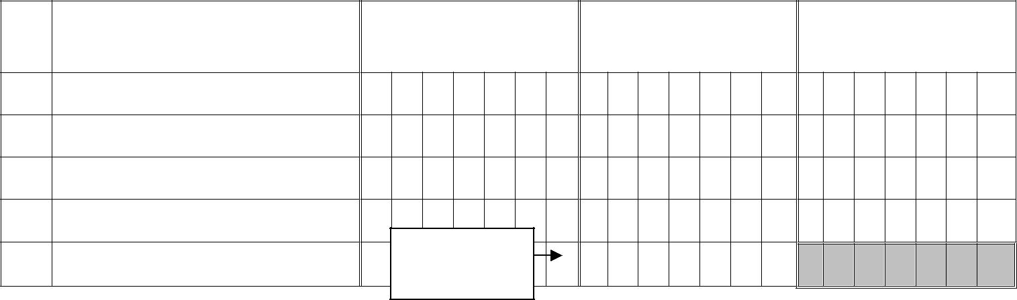

|  |  |  |  |
| --- | --- | --- | --- |
| Rate wise details of the | Purchase Value | Fair Market Value* | Tax Payable (Rs.) |
| Trading Stock | (Rs.) | (Rs.) |  |

1. Goods taxable at 1%
2. Goods taxable at 4%
3. Goods taxable at 12.5%
4. Goods taxable at 20%

E Total

(* As at 1st April of the current year)

**(ii)** Details of Raw Material as at 1stApril, _________ of the current year and tax payable thereon.

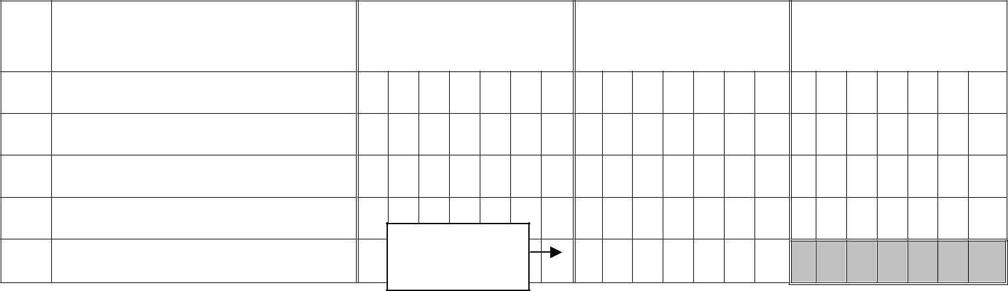

|  |  |  |  |
| --- | --- | --- | --- |
| Rate wise details of the Raw | Purchase Value | Fair Market Value* | Tax Payable (Rs.) |
| Material | (Rs.) | (Rs.) |  |

1. Goods taxable at 1%
2. Goods taxable at 4%
3. Goods taxable at 12.5%
4. Goods taxable at 20%

Carry to main

E Total form 7(ii)

(* As at 1st April of the current year)

**(iii)** Details of Packaging Material as at 1stApril, _________ of the current year and tax payablethereon.

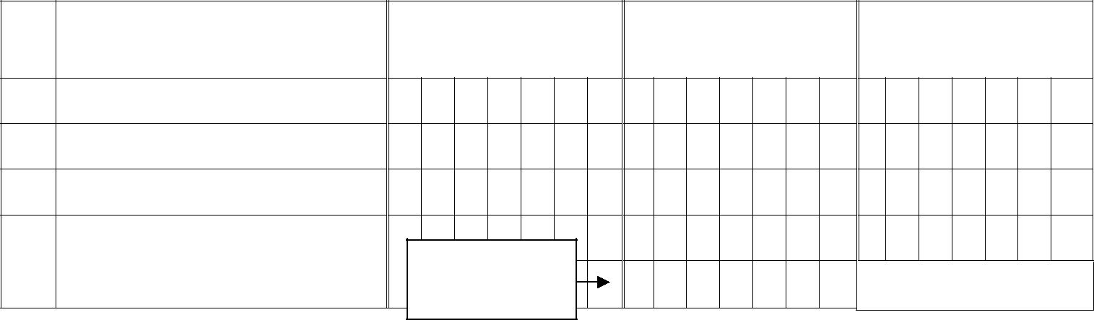

|  |  |  |  |
| --- | --- | --- | --- |
| Rate wise details of the | Purchase Value | Fair Market Value* | Tax Payable (Rs.) |
| Packaging Material | (Rs.) | (Rs.) |  |

1. Goods taxable at 1%
2. Goods taxable at 4%
3. Goods taxable at 12.5%
4. Goods taxable at 20%

|  |  |  |  |  |  |  |  |  |  |  |  |  |
| --- | --- | --- | --- | --- | --- | --- | --- | --- | --- | --- | --- | --- |
|  |  |  |  | Carry to main |  |  |  |  |  |  |  |  |
| E | Total |  |  |  |  |  |  |  |  |
|  |  | form to (7)(iii) |  |  |  |  |  |  |  |  |
|  |  |  |  |  |  |  |  |  |  |  |  |  |

(* As at 1st April of the current year)

**(iv)** Details of Finished Goods as at 1stApril, _______ of the current year and tax payable thereon.



|  |  |  |  |
| --- | --- | --- | --- |
| Rate wise details of the | Purchase Value | Fair Market Value* | Tax Payable (Rs.) |
| Packaging Material | (Rs.) | (Rs.) |  |

1. Goods taxable at 1%
2. Goods taxable at 4%
3. Goods taxable at 12.5%
4. Goods taxable at 20%

|  |  |  |  |  |  |  |  |  |  |  |  |  |  |  |
| --- | --- | --- | --- | --- | --- | --- | --- | --- | --- | --- | --- | --- | --- | --- |
|  |  |  |  | Carry to main |  |  |  |  |  |  |  |  |  |  |
| E | Total |  |  |  |  |  |  |  |  |  |
|  |  |  |  |  |  |  |  |  |
|  |  | form to (7)(iv) |  |  |  |  |  |  |  |  |  |  |
|  |  |  |  |  |  |  |  |  |  |  |  |  |  |  |

(* As at 1st April of the current year)

**V.** Verification

I/We __________________________________________ hereby solemnly affirm and declare that the information given hereinabove is true and correct to the best of my/our knowledge and belief and nothing has been concealed therefrom.

|  |  |  |  |  |  |  |  |  |  |  |  |  |  |  |  |  |  |  |  |  |  |  |  |  |  |  |  |  |  |  |  |
| --- | --- | --- | --- | --- | --- | --- | --- | --- | --- | --- | --- | --- | --- | --- | --- | --- | --- | --- | --- | --- | --- | --- | --- | --- | --- | --- | --- | --- | --- | --- | --- |
|  | Signature of Authorised Signatory | | | | | | | | | | | |  |  |  |  | _______________________________________ | | | | | | | | | | | | |  |  |
|  | Full Name *(first name, middle, surname)* | | | | | | | | | | | | | | | | _______________________________________ | | | | | | | | | | | | |  |  |
|  |  |  |  |  |  |  |  |  |  |  |  |  |  |  |  |  |  |  |
|  | Designation/Status | | |  |  |  |  |  |  |  |  |  |  |  |  |  | _______________________________________ | | | | | | | | | | | | |  |  |
|  |  |  |  |  |  |  |  |  |  |  |  |  |  |  |  |  |  |  |  |  |  |  |  |  |  |  |  |  |  |  |  |
|  |  |  |  |  |  |  |  |  |  |  |  |  |  |  |  |  |  |  |  |  |  |  |  |  |  |  |  |  |  |  |  |
|  | Place |  |  |  |  |  |  |  |  |  |  |  |  |  |  |  |  |  |  |  |  |  |  |  |  |  |  |  |  |  |  |
|  |  |  |  |  |  |  |  |  |  |  |  |  |  |  |  |  |  |  |  |  |  |  |  |  |  |  |  |  |  |  |  |
|  |  | |  |  |  |  |  |  |  |  |  |  |  |  |  |  |  |  |  |  |  |  |  |  |  |  |  |  |  |  |  |
|  | Date |  |  |  |  |  |  |  |  |  |  |  |  |  |  |  |  |  |  |  |  |  |  |  |  |  |  |  |  |  |  |
|  |  |  |  |  |  |  |  |  | |  | |  |  |  | |  |  |  |  |  |  |  |  |  |  |  |  |  |  |  |  |
|  |  | Day | |  |  |  | Month | | |  | |  |  | Year | | |  |  |  |  |  |  |  |  |  |  |  |  |  |  |  |
|  |  |  |  |  |  |  |  |  |  |  |  |  |  |  |  |  |  |  |  |  |  |  |  |  |  |  |  |  |  |  |  |